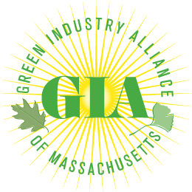

H.1874/S.1221 – AN ACT RELATIVE TO SNOW REMOVAL SERVICE LIABILITY LIMITATION

ISSUE: Property owners and managers are using abusive indemnification or hold harmless clauses in their contracts with subcontractors that limits their ability to safely manage the grounds and pushes liability for any claims to the subcontractor. Subcontractors are forced to assume liability while being restricted from plowing in certain conditions. Specifically, the snow removal contracts prevent the operator from plowing unless an arbitrary amount of snow has accumulated, in some cases as much as 2 inches, but puts all the liability on the local, snow removal provider.

IMPACTED PARTIES: The Green Industry Alliance of Massachusetts is comprised of the Massachusetts Arborists Association (MAA), the Massachusetts Association of Landscape Professionals (MALP), the Massachusetts Association of Lawn Care Professionals (MALCP), and the Golf Course Superintendents Association of New England (GCSANE).

Many of the member companies are also members of the Accredited Snow Contractors Association (ASCA) and are primarily small to medium size businesses based in local communities across the Commonwealth. A lack of competition among insurance carriers is forcing prices to dramatically increase – one local company saw their premiums go from $14,000 to $91,000 over the past 5 years. Other local companies have been dropped by their insurance carrier and left to a small number of options, all very expensive. This dramatic increase in the cost of doing business is made even worse when snow-plow companies enter multi-year contracts at fixed prices.

MAJOR BENEFITS:

- Establishes clear and fair lines for the assumption of liability regarding claims of injury
- Protects local snow removal operators from exorbitant insurance premiums
- Ensures the citizens of Massachusetts will have safe and appropriately cleared surfaces in winter
- Promotes a level playing field and sustainable, competitive insurance practices
- Nationally, there are 30,000 snow and ice related slip and fall claims each year: 35% are frivolous, 72% of the rest are lost or settled for $20,000 or less and makes for a very challenging environment

OTHER STATES: Similar legislation has been enacted in in Illinois, Colorado, Connecticut, New Jersey and Pennsylvania.

URGENT ACTION NEEDED: This legislation received a favorable recommendation from the Joint Committee on Labor and Workforce Development. We need your help to push it forward in 2024!

